Jira Ticket

*IBM - QRadar ID:* (55230.)
*Description*
(ET WEB_SERVER Script tag in URI, Possible Cross Site Scripting Attempt)
*Encoded log:*
(<168>suricata[8969]: {"timestamp":"2025-08-05T10:32:33.872706-0400","flow_id":636450097984898,"in_iface":"eth0","event_type":"alert","src_ip":"77.111.246.48","src_port":44279,"dest_ip":"38.242.128.144","dest_port":80,"proto":"TCP","tx_id":0,"alert":{"action":"allowed","gid":1,"signature_id":2009714,"rev":5,"signature":"ET WEB_SERVER Script tag in URI, Possible Cross Site Scripting Attempt","category":"Web Application Attack","severity":1},"http":{"hostname":"oldsystem.cydeosec.com","url":"/search.php?searchdata=%3Cscript%3Ealert%28%27HACKED%21%27%29%3C%2Fscript%3E&search=","http_user_agent":"Mozilla/5.0 (Windows NT 10.0; Win64; x64) AppleWebKit/537.36 (KHTML, like Gecko) Chrome/135.0.0.0 Safari/537.36 OPR/120.0.0.0","http_content_type":"text/html","http_refer":"http://oldsystem.cydeosec.com/search.php","http_method":"GET","protocol":"HTTP/1.1","status":200,"length":1140}})
*Decoded log:* I use code beautify to convert payload to readable format
(
timestamp | : | 2025-08-05T10:32:33.872706-0400

 | flow_id | : | 636450097984898  +022138-04-20T13:53:04.898Z

 | in_iface | : | eth0

 | event_type | : | alert

 | src_ip | : | 77.111.246.48

 | src_port | : | 44279

 | dest_ip | : | 38.242.128.144

 | dest_port | : | 80

 | proto | : | TCP

 | tx_id | : | 0

 | alert |  | {7}

 | http |  | {9}

 | hostname | : | oldsystem.cydeosec.com

 | url | : | /search.php?searchdata=%3Cscript%3Ealert%28%27HACKED%21%27%29%3C%2Fscript%3E&search=

 | http_user_agent | : | Mozilla/5.0 (Windows NT 10.0; Win64; x64) AppleWebKit/537.36 (KHTML, like Gecko) Chrome/135.0.0.0 Safari/537.36 OPR/120.0.0.0

 | http_content_type | : | text/html

 | http_refer | : | http://oldsystem.cydeosec.com/search.php

 | http_method | : | GET

 | protocol | : | HTTP/1.1

 | status | : | 200

 | length | : | 1140

.)

*ATTACKER INFO:*
*IP:* (77.111.246.48)
*User Agent:* Statcounter.com - Useragent Detect | StatCounter Global Stats
*User Agent:* (Mozilla/5.0 (Windows NT 10.0; Win64; x64) AppleWebKit/537.36 (KHTML, like Gecko) Chrome/135.0.0.0 Safari/537.36 OPR/120.0.0.0)
*Browser Name:* (Opera)
*Browser Version:* (120.0.)
*OS:* (Win10)

*ANALYST INVESTIGATION:*
*Virus Total Result:* (VirusTotal - IP address - 77.111.246.48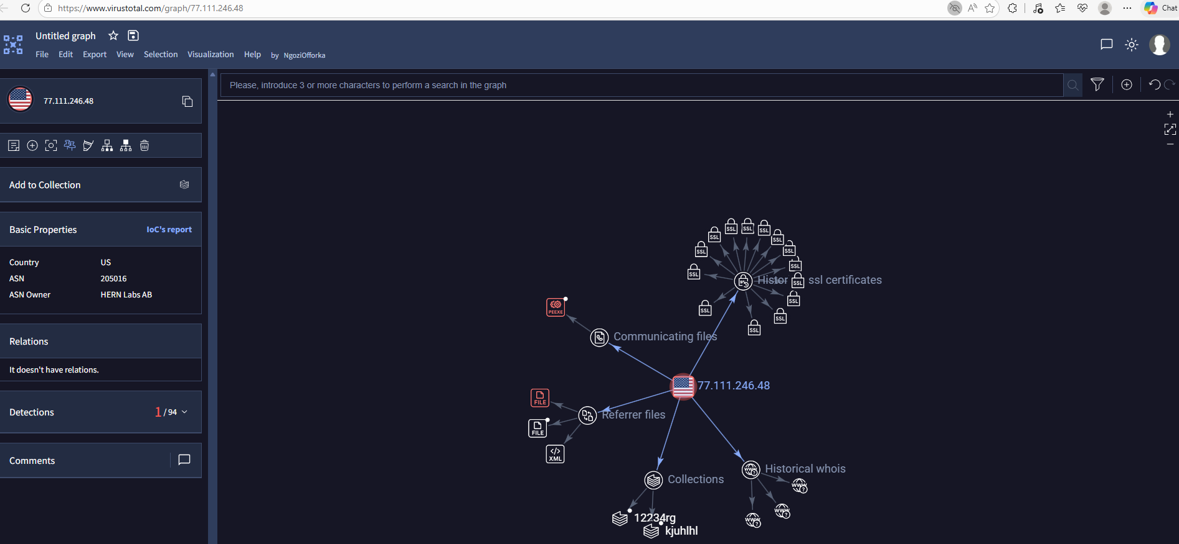
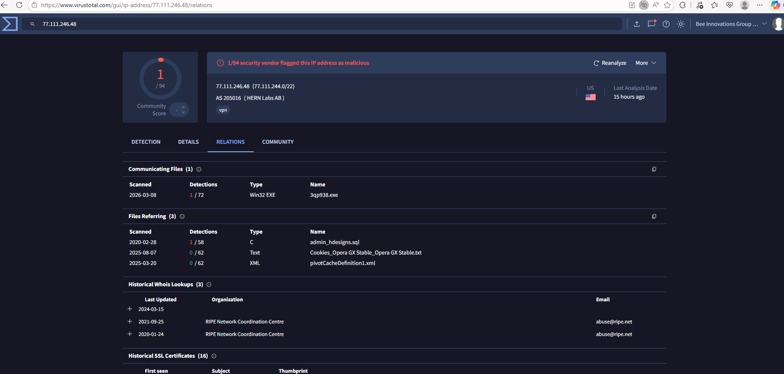
*Brief Community Comments:* (The IP address was analyzed on VirusTotal, where the community section shows that one user previously reported the IP as malicious. Community reports typically come from security researchers or analysts who have encountered suspicious activity. This indicates the IP address has already been flagged by another investigator as potentially involved in malicious activity.)
*Security Vendors' Analysis from Virus Total:* (Further analysis of the VirusTotal relations and graph summary shows that the IP address is linked to multiple files classified as phishing, backdoor scripts, and malicious files. Some of these files were detected as 100% malicious by security vendors, indicating strong evidence that the IP address is associated with malicious infrastructure.

*Talos Intelligence:*/Abuse IPDB Reputation Lookup || Cisco Talos Intelligence Group - Comprehensive Threat Intelligence
*REPUTATION DETAILS:* (Investigate the IP on Talos. You can share your findings here like below example:
Email Reputation: Neutral
Web Reputation: Neutral
*BLOCK LISTS:*
BL.SPAMCOP.NET: *Not Listed*
CBL.ABUSEAT.ORG: *Listed*
PBL.SPAMHAUS.ORG: *Not* *Listed*
SBL.SPAMHAUS.ORG: *Not Listed*
*Shodan Result:* (77.111.246.48
The IP address was investigated using Shodan. The results show the IP originates from United States, specifically Osborne, Kansas. It is associated with Opera Software, with the Internet Service Provider identified as Hemlab AB. The IP communicates over TCP port 443, which is commonly used for secure HTTPS traffic.
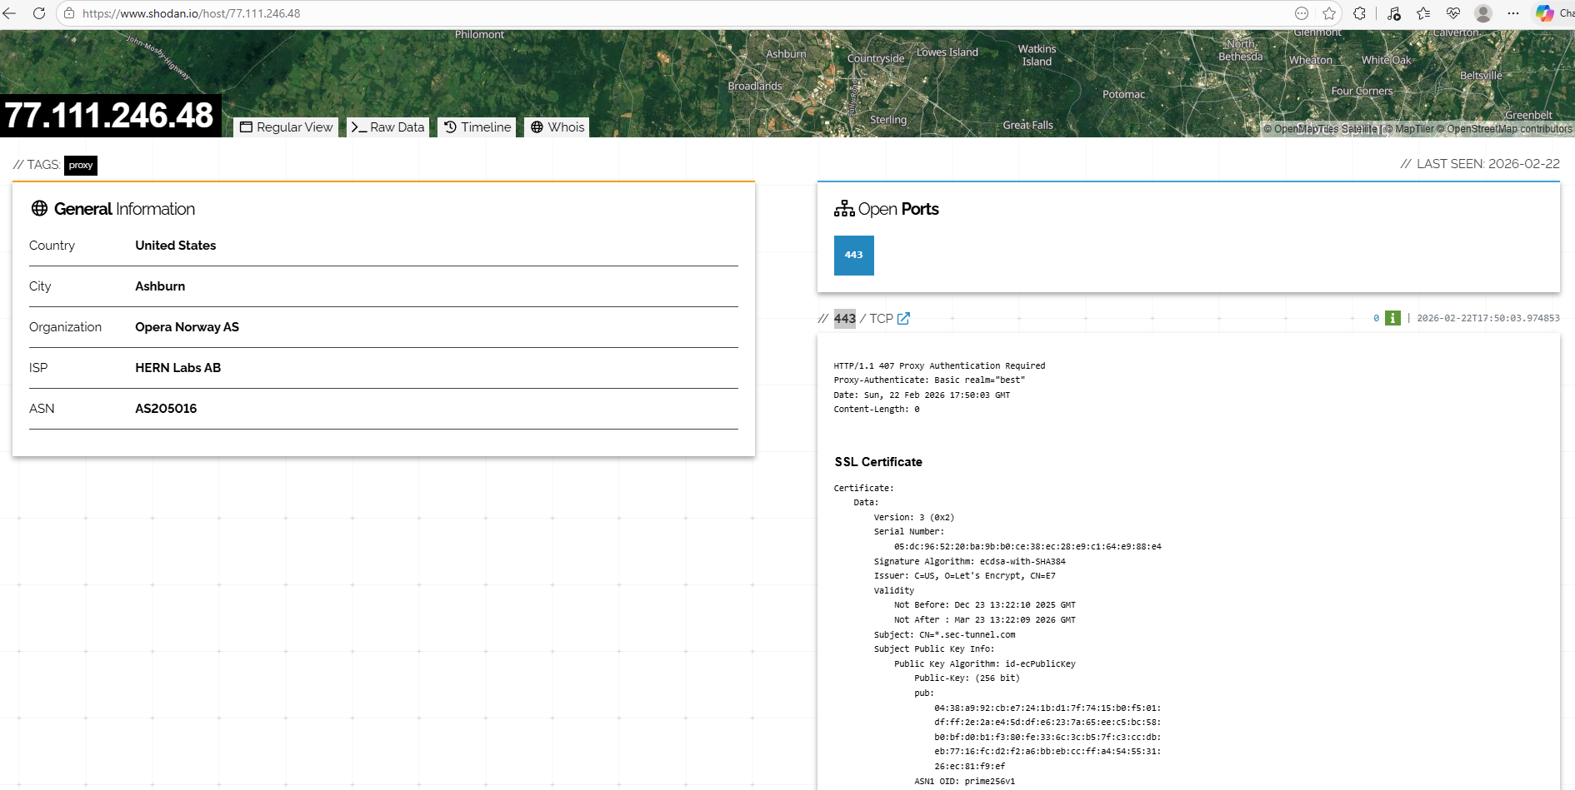
*Open Ports:* 443
*Victim:* (38.242.128.144)
URL Scan : A request contained a URL-encoded payload <script>alert('HACKED!')</script> in the searchdata parameter of search.php. This indicates a possible reflected Cross-Site Scripting (XSS) probe, where an attacker attempts to inject JavaScript into a web application to see if it executes in a user’s browser.
ANYRUN SCAN - Analysis URL SCAN -Anyrun.docx (MD5: 9877334CE952E65853BEB31508A61DA7) No threats detected - Interactive analysis ANY.RUN
/search.php?searchdata=%3Cscript%3Ealert%28%27HACKED%21%27%29%3C%2F[.]script%3E&search=

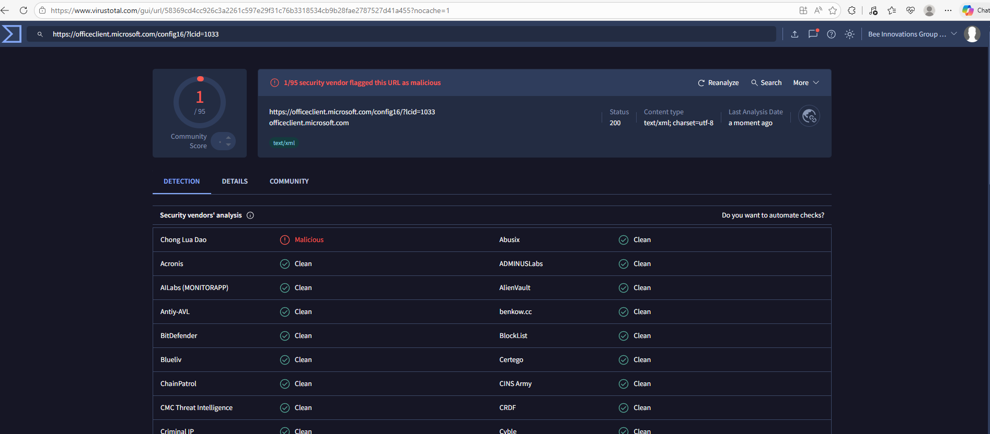

The URL was analyzed in the Any.Run sandbox and no threats were detected. However, after reviewing the Indicators of Compromise (IOC), some associated URLs were extracted and checked on VirusTotal, where one of the URLs was flagged as malicious by multiple security vendors.

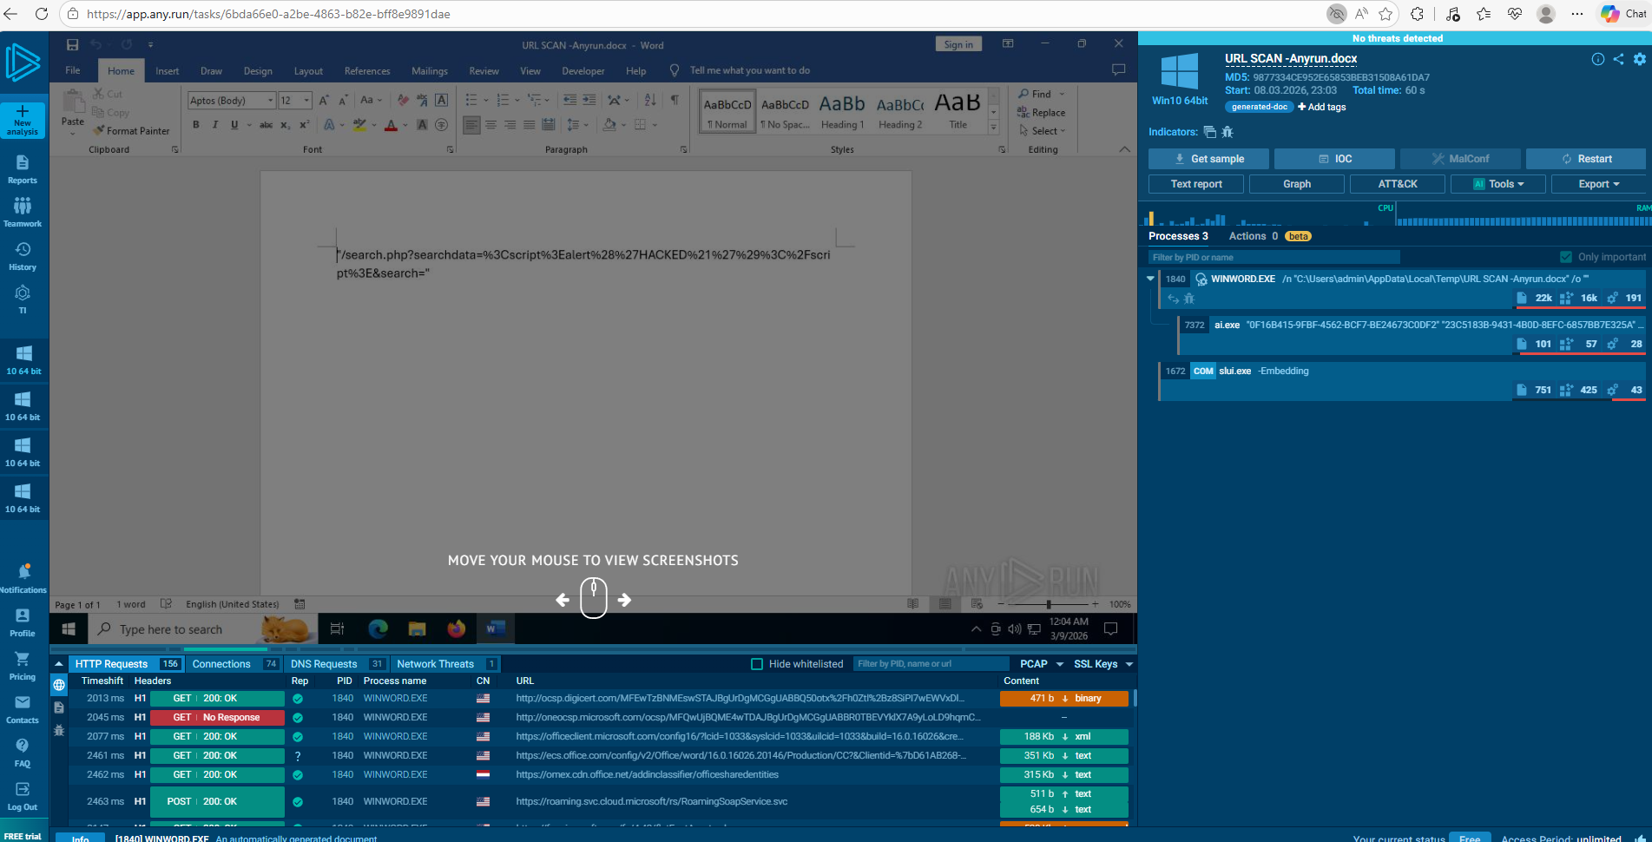

*Splunk Investigation::
Related Event on Splunk (344)
Peak Events on August 5, 25

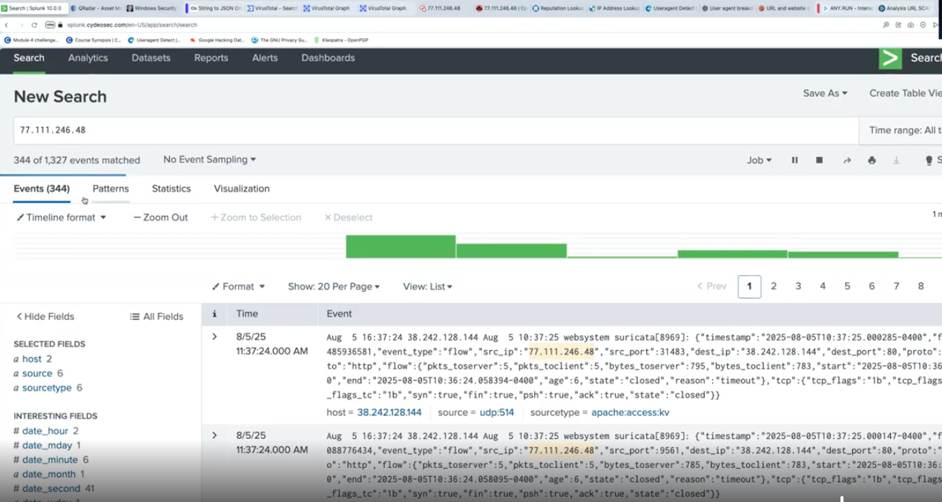
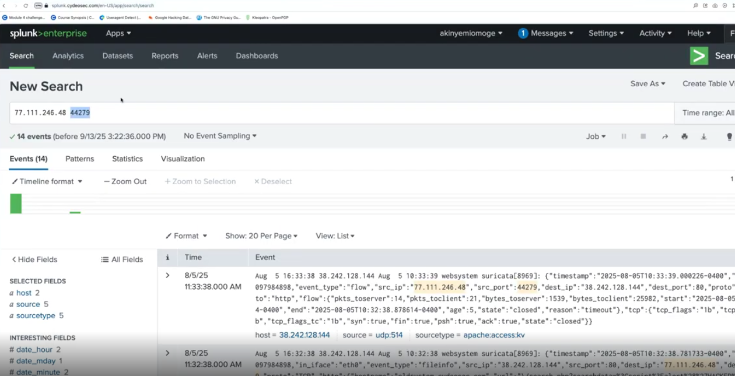

*ANALYST ASSESTMENT*

Investigation Conclusion
The alert triggered in IBM QRadar shows a possible Cross-Site Scripting (XSS) probing attempt against the web application. The request contained an encoded script payload (<script>alert('HACKED!')</script>) within the searchdata parameter of the /search.php page, which is commonly used by attackers to test if a web application is vulnerable to script injection.
At this time, there is no evidence of a successful compromise. The activity appears to be a reconnaissance or vulnerability testing attempt rather than an executed attack.

Indicators of Compromise (IOC)
- Source IP: 77.111.246.48
- Encoded XSS payload detected in URL parameter
- VirusTotal community flagged the IP as suspicious
- IP linked to phishing and malicious files in threat intelligence sources
- 344 related events observed in Splunk logs

Recommendation
Continue monitoring activity from the source IP and review web server logs for similar attempts. If the behavior continues, consider blocking the IP and ensuring proper input validation or WAF protections are in place to prevent XSS attacks.

